**Getting started with “*HACK CHALLENGE*”**

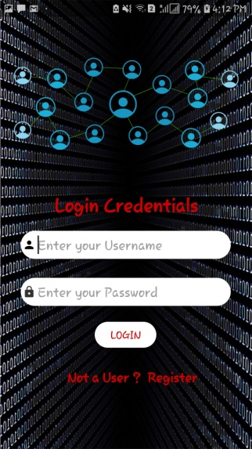 **After opening the Gaming Application, the first page that comes up is the login page. You can only login if you are already registered, or else you need to press the Register button.**

.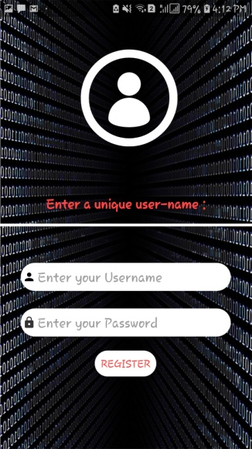

**The page pops up when you strike the register button for you to sign up.**

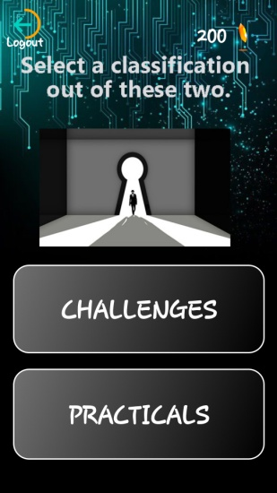

**This is the *Home Page* where you’ll find two categories:**

**1) Challenges 2) Practicals**

**Initially users will receive 200 coins by default. There are some aspects that you should take into account:**

**If you accomplish a level, then you score 150 coins.**

**If you answer incorrectly, then you lose 50 coins.**

**If you hit the *Hint Button*, then you lose 50 coins.**

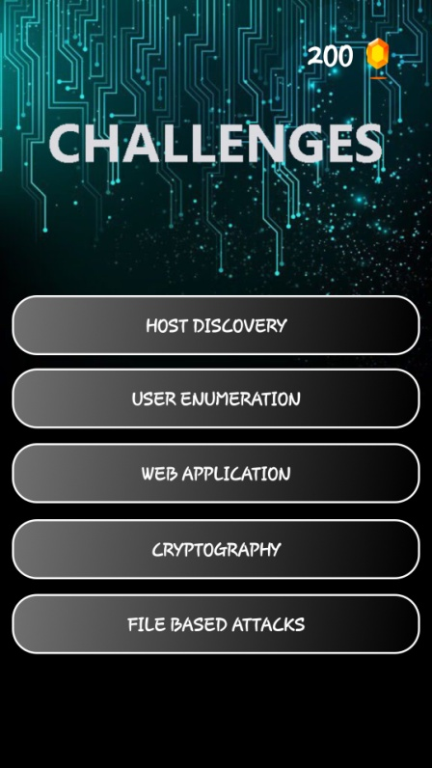

**1**

**2**

**3**

**4**

**5**

**The first division is based on challenges which mostly requires linux knowlwdge. The category is further divided into five sub-categories.**

1. **Host Discovery-**
2. **User Enumeration-**
3. **Web Application-**
4. **Cryptography-**
5. **File Based Attacks-**

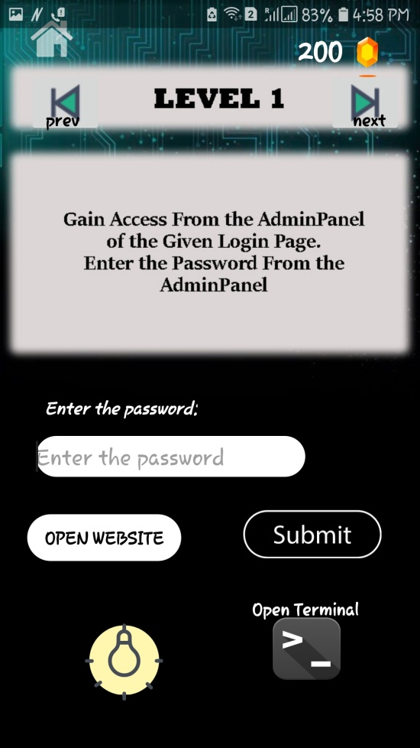

**1**

**2 3**

**4 5**

1. **Input Field-**
2. **Website-**
3. **Submit Button-**
4. **Hint Button-**
5. **Termux Button-**

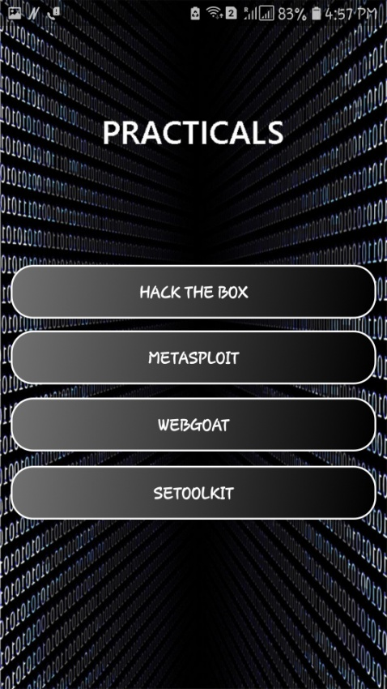

**1**

**2**

**3**

**4**

1. **Hack The Box-** Hack The Box is an online platform allowing you to test your penetration testing skills and exchange ideas and methodologies with other members of similar interests. It contains several challenges that are constantly updated, now if you want to start using it and you aren’t familiar with something like that. You’ll get confused coz there’s no signup like form there. There’s only a join page which asks for invite code and invite code is the key for signup.
2. **Metasploit-** The Metasploit Project is a computer security project that provides information about security vulnerabilities and aids in penetration testing and IDS signature development. Its best-known sub-project is the open-source. Metasploit Framework, a tool for developing and executing exploit code against a remote target machine. Other important sub-projects include the Opcode Database, shellcode archive and related research. The Metasploit Project includes anti-forensic and evasion tools, some of which are built into the Metasploit Framework. Metasploit is pre-installed in the Kali Linux operating system.
3. **WebGoat**- WebGoat is a deliberately insecure web application maintained by OWASP designed to teach web application security lessons. You can install and practice with WebGoat. There are other 'goats' such as WebGoat for .Net. In each lesson, users must demonstrate their understanding of a security issue by exploiting a real vulnerability in the WebGoat applications.
4. **SE Tool Kit**- The Social-Engineer Toolkit is an open-source penetration testing framework designed for social engineering. SET has a number of custom attack vectors that allow you to make a believable attack quickly. SET is a product of TrustedSec, LLC – an information security consulting firm located in Cleveland, Ohio.